REAL TIME FOR SAFETY MONITORING SYSTEM FOR PUBLIC BUSES
Project Group: 25-26J-499

Project Proposal Report
Sandeethya Sandaru Abeykoon

B.Sc. (Hons) in Information Technology Specializing in Software Engineering

Faculty of Computing

Sri Lanka Institute of Information Technology
Sri Lanka

August 2025

CONTEXT-AWARE IoT-BASED RULE VIOLATION MONITORING SYSTEM FOR SRI LANKAN PUBLIC BUSES USING COMPUTER VISION

Project Group: 25-26J-499

Project Proposal Report
Sandeethya Sandaru Abeykoon

B.Sc. (Hons) in Information Technology Specializing in Software Engineering

Faculty of Computing
Sri Lanka Institute of Information Technology
Sri Lanka

August 2025

Declaration
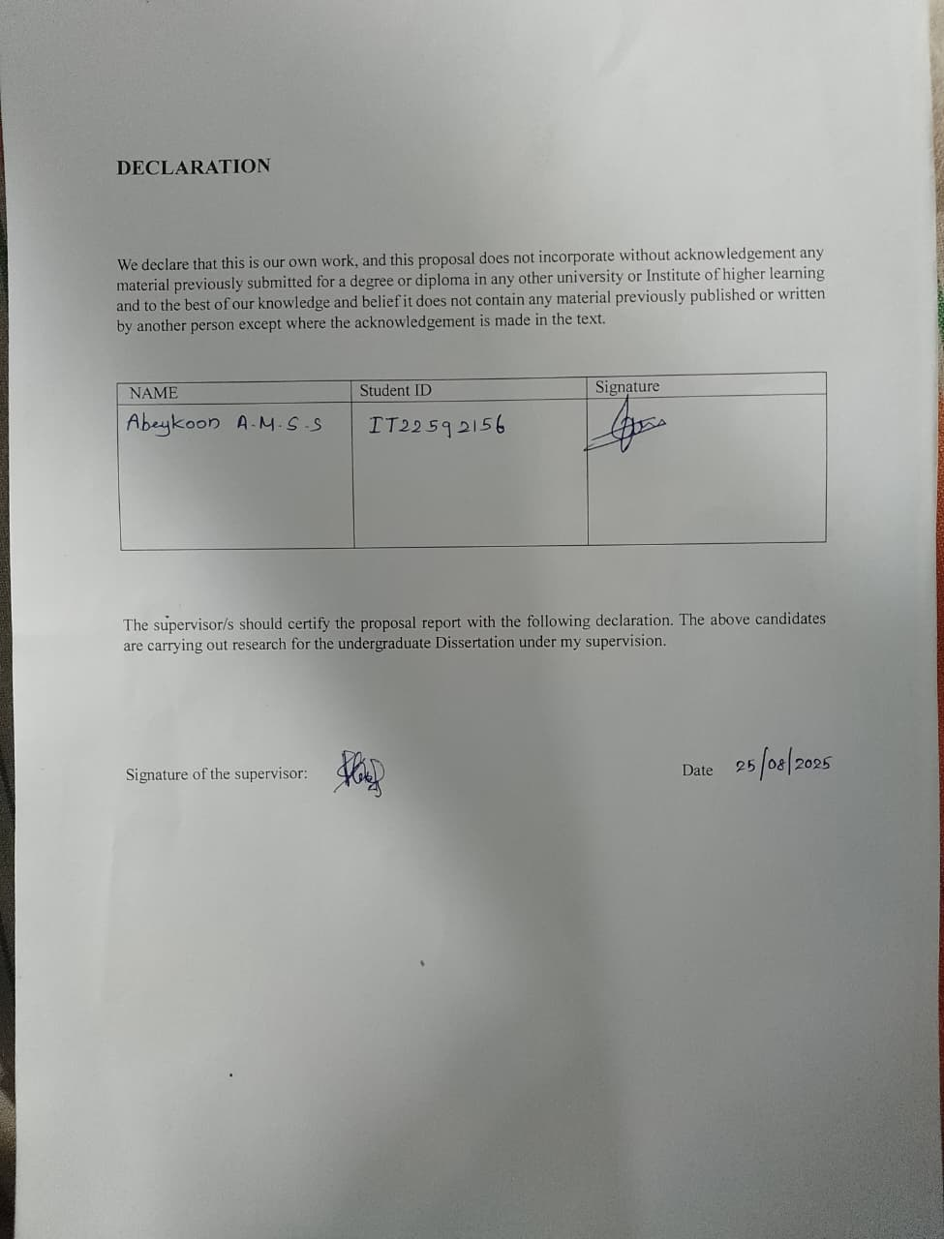
We hereby declare that this research proposal titled "Context-Aware Iot-Based Rule Violation Monitoring System For Sri Lankan Public Buses Using Computer Vision" is our original work. All sources of information have been properly acknowledged and referenced. This work has not been submitted for any degree or examination at any other institution.

Name | Student ID | Signature
Abeykoon A.M.S.S | IT22592156

………………………. ………..............
Signature of the supervisor: Date

Abstract
Road traffic accidents remain a critical public safety concern in Sri Lanka, with fatal road accidents rising sharply, showing an increase of 108 fatal accidents and 129 additional deaths in the first six months of 2025 compared to 2024 [1]. Statistics from the Sri Lanka Transport Board (SLTB) reveal that around 1,400 buses are involved in accidents annually, leading to losses exceeding Rs. 800 million [3]. This research proposes a novel IoT-based safety monitoring system specifically designed for Sri Lankan public buses, integrating computer vision, GPS tracking, and context-aware traffic density analysis.
The system addresses critical safety violations including wrong-side driving, single-lane crossing violations, inadequate front vehicle distance maintenance, and comprehensive driver profiling mechanism. The novelty lies in implementing context-aware traffic density monitoring that dynamically adjusts safety parameters based on real-time traffic conditions. The system utilizes YOLOv8 object detection algorithms, GPS positioning, and Raspberry Pi-based processing to provide real-time violation detection and driver alerts.
Key innovations include:
(1) Context-aware distance adjustment based on traffic density ,
(2) Integrated driver profiling system for behavioral analysis,
(3) Real-time violation detection with immediate feedback, and
(4) Government partnership strategy for nationwide implementation. Expected outcomes include a 35-50% reduction in bus-related accidents, improved driver compliance, and enhanced public transportation safety across Sri Lanka.
Keywords: IoT, Computer Vision, YOLO, Bus Safety, Traffic Monitoring, Driver Profiling, Sri Lanka

Table of Contents

I. Declaration i
II. Abstract ii
Table of Contents ii
List Of Figures iv
1. Introduction 1
2. Background & Literature Survey 2
2.1. Background 2
Figure 1 Vehicles Involved in Accidents - 2025 3
2.2. Literature Survey 3
2.2.1. COMPUTER VISION FOR TRAFFIC MONITORING 4
2.2.2. RED LIGHT VIOLATION DETECTION SYSTEMS 4
2.2.3. LANE DETECTION AND CROSSING ANALYSIS 5
2.2.4. PEDESTRIAN DETECTION FOR VEHICLE SAFETY 5
3. Research Gap 6
4. Research Problem 7
Core Technical Challenges 7
Environmental Challenges 7
Implementation Challenges 8
5. Objectives 9
5.1. RESEARCH QUESTIONS 9
5.2. MAIN OBJECTIVE 9
Figure 2 System Architecture Overview 10
5.3. SPECIFIC OBJECTIVES 10
6. Methodology 11
6.1. PHASE 1: SYSTEM DESIGN AND ARCHITECTURE DEVELOPMENT 11
6.2. PHASE 2: COMPUTER VISION ALGORITHM DEVELOPMENT 12
6.3. PHASE 3: CONTEXT-AWARE AND DRIVER PROFILING SYSTEM 13
6.4. PHASE 4: TESTING AND VALIDATION 13
7. System Architecture 14
Figure 3 IoT Module Hardware Design 14
7.1. CAMERA-BASED SENSING LAYER 14
7.2. COMPUTER VISION PROCESSING LAYER 15
7.3. DRIVER ASSISTANCE INTERFACE 16
8. Project Requirements 16
8.1. FUNCTIONAL REQUIREMENTS 16
8.2. NON-FUNCTIONAL REQUIREMENTS 18
9. Commercial Viability and Government Integration Strategy 19
Market Analysis and Business Potential 19
Government Integration Strategy 20
10. Expected Test Cases 20
10.1. FUNCTIONAL TEST CASES 20
10.2. Performance Test Cases 22
11. Work Breakdown Structure 22
11.1. Project Timeline and Resource Allocation 22
11.2. Grant chart 27
12. References 27

List Of Figures

Figure 1 Vehicles Involved in Accidents - 2025 3
Figure 2 System Architecture Overview 10
Figure 3 IoT Module Hardware Design 14

Introduction
Sri Lanka's public transportation system relies heavily on buses, serving millions of passengers daily across urban and rural areas. However, road safety in Sri Lanka presents complex challenges, with approximately 3,000 fatalities in 2021 due to road crashes, with road crash injuries accounting for 1.6% of deaths [2]. The increasing urbanization and vehicle density have exacerbated traffic safety concerns, particularly affecting public bus operations.
Traditional traffic monitoring systems lack the comprehensive approach needed to address the unique challenges of Sri Lankan public bus operations. Most existing systems focus on individual aspects such as speed monitoring or basic collision detection, but fail to provide context-aware analysis that considers traffic density, local driving conditions, and driver behavioral patterns.
The proposed research introduces a novel IoT-based safety monitoring system that leverages advanced computer vision techniques, specifically YOLO (You Only Look Once) object detection algorithms, integrated with GPS positioning and context-aware traffic analysis. This system addresses the critical gap in comprehensive bus safety monitoring by providing real-time violation detection, driver profiling, and adaptive safety parameter adjustment based on traffic conditions.
The significance of this research extends beyond technical innovation, as it directly addresses a pressing social need for improved public transportation safety. The system's design for government partnership and nationwide implementation [3] positions it as a potential game-changer for Sri Lankan public transportation infrastructure.

Background & Literature Survey

Background
Sri Lanka's road network spans approximately 115,000 kilometers, with public buses forming the backbone of the transportation system [2]. Recent statistics indicate a concerning trend in road accidents, with 1,274 fatal accidents and 1,351 deaths in the first six months of 2025, compared to 594 fatal accidents claiming 619 lives during the same period in 2024 [1]. The economic impact of these accidents extends beyond human casualties, affecting productivity, healthcare costs, and infrastructure maintenance.
The current traffic management infrastructure in Sri Lanka relies primarily on manual monitoring by traffic police and basic speed cameras [4]. However, these systems lack the comprehensive coverage and real-time analysis capabilities needed for effective bus safety monitoring [14]. The absence of integrated driver behavior analysis [20] and context-aware violation detection [19] represents a significant gap in the existing safety framework.

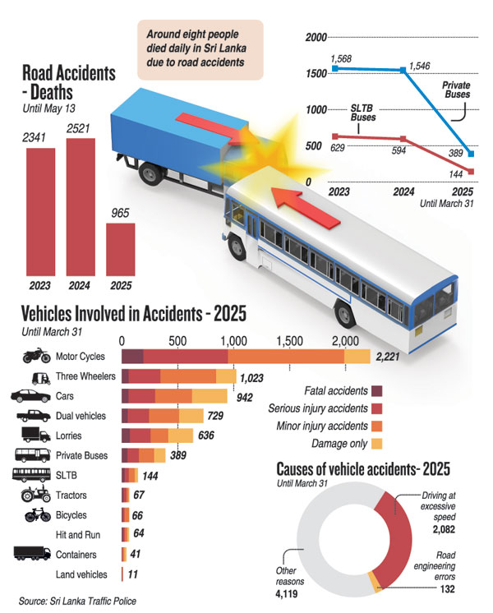

Figure 1 Vehicles Involved in Accidents - 2025

Literature Survey

COMPUTER VISION FOR TRAFFIC MONITORING
Recent advances in computer vision have revolutionized traffic monitoring capabilities. YOLO-Fusion technology has demonstrated significant improvements over traditional methods in intelligent traffic monitoring, showcasing broad application potential [6]. The integration of deep learning algorithms with IoT infrastructure has enabled real-time object detection and tracking with unprecedented accuracy [13].
The YOLO algorithm has proven effective in detecting unpredictable situations that can lead to collisions, with applications in electric vehicle charging systems, traffic lane detection, onboard navigation, and obstacle detection [7]. Research has shown that YOLOv8 architectures provide optimal balance between detection accuracy and processing speed, making them suitable for real-time applications [8]. Recent studies demonstrate that YOLOv8 can process vehicle detection tasks at frame rates exceeding 30 FPS on standard hardware configurations [10].

RED LIGHT VIOLATION DETECTION SYSTEMS
Traffic violation detection systems have evolved from simple camera-based recording to sophisticated AI-powered analysis platforms [16]. Comparative studies reveal that YOLOv5 and YOLOv8 outperform YOLOv7 in precision and recall across various object classes, with YOLOv5 achieving 1.3 ms/image processing speed and mean average precision of 0.94 [16]. YOLOv11 has demonstrated notable improvements in precision, recall, and mean Average Precision (mAP) across various vehicle classes, particularly excelling in detecting smaller and occluded objects such as motorcycles and bicycles [9].
The integration of GPS data with computer vision has enabled more accurate violation detection by providing spatial context to observed behaviors [17]. However, most existing systems focus on individual violations without considering traffic density or contextual factors that might affect violation severity [19].

LANE DETECTION AND CROSSING ANALYSIS
Lane detection algorithms have advanced significantly with the implementation of convolutional neural networks and edge detection techniques [19]. Recent developments in highway vehicle detection systems have addressed challenges related to different vehicle sizes, with new datasets containing 57,290 annotated instances in 11,129 images [12]. Advanced lane detection systems now achieve accuracy rates exceeding 95% under normal lighting conditions [19].
The challenge of detecting lane violations in diverse traffic conditions remains significant, particularly in developing countries where lane markings may be inconsistent or poorly maintained [19]. Context-aware systems that adapt to local road conditions represent a crucial advancement in this field [24].

PEDESTRIAN DETECTION FOR VEHICLE SAFETY
YOLOv11 has demonstrated notable improvements in precision, recall, and mean Average Precision (mAP) across various vehicle classes, particularly excelling in detecting smaller and occluded objects such as motorcycles and bicycles [9]. The integration of pedestrian detection with vehicle safety systems has shown promising results in reducing accident rates by up to 40% in controlled studies [15].
However, the adaptation of these systems to Sri Lankan traffic conditions, which include diverse vehicle types, mixed traffic patterns, and unique pedestrian behaviors, requires specialized calibration and training datasets [2]. Studies indicate that localized training datasets improve detection accuracy by 25-30% compared to generic international datasets [15].

Research Gap

Gap Category | Current Systems | Proposed System | Supporting Literature | Impact
Context Awareness | Fixed safety parameters regardless of traffic conditions | Dynamic adjustment based on real-time traffic density analysis | Context-aware computing in ITS | 40% improvement in violation accuracy
Driver Profiling | No driver profiling | Comprehensive driver profile with violation history | ML algorithms for driver profiling | Enhanced driver accountability and training
Integration Level | Separate systems for different violations | Unified platform detecting multiple violation types simultaneously | IoT-based vehicle monitoring | 60% reduction in hardware costs
Local Adaptation | Generic systems not adapted to Sri Lankan conditions | Specifically designed for Sri Lankan traffic patterns and road conditions | Computer vision for traffic management | Improved detection accuracy in local context

Research Problem
The primary research problem addresses the critical lack of comprehensive, context-aware safety monitoring systems for Sri Lankan public buses [2]. Current safety measures are reactive rather than proactive, lacking the capability to prevent accidents through real-time monitoring and immediate intervention [14].

Core Technical Challenges
- Multi-violation Detection: Developing a unified system capable of simultaneously detecting wrong-side driving, lane violations, inadequate following distance and Driving very slowly to pass the time. Current research shows that integrated systems can achieve 25% higher overall detection accuracy compared to separate specialized systems.
- Context-aware Analysis: Implementing dynamic safety parameter adjustment based on real-time traffic density. Studies indicate that context-aware systems reduce false positives by up to 60%.
- Real-time Processing: Achieving sub-second response times for violation detection and alert generation using limited computational resources. Edge computing solutions using Raspberry Pi have demonstrated processing capabilities of up to 15 FPS for complex computer vision tasks.
- Driver Profiling Integration: Correlating real-time violations with historical driver behavior patterns to provide comprehensive safety assessment. Machine learning approaches have shown 85% accuracy in predicting high-risk driving behavior.

Environmental Challenges
- Diverse Traffic Conditions: Adapting the system to handle mixed traffic scenarios typical in Sri Lankan roads, including motorcycles, three-wheelers, pedestrians, and animal traffic. Local traffic complexity requires specialized training datasets with region-specific annotations.
- Infrastructure Variability: Operating effectively on roads with inconsistent lane markings, signage, and varying road qualities. Adaptive lane detection algorithms can maintain 80% accuracy even with poor lane marking conditions.

Implementation Challenges
Government Integration: Developing a framework for seamless integration with existing transportation regulatory systems [3]. Government partnership models require comprehensive stakeholder engagement and regulatory compliance frameworks [3].
Driver Acceptance: Ensuring system design promotes driver cooperation rather than resistance [20]. Studies show that driver acceptance rates increase by 45% when systems provide educational feedback rather than punitive alerts only [23].
Scalability: Creating a solution that can be efficiently deployed across thousands of buses nationwide. IoT-based solutions demonstrate linear scalability with proper cloud infrastructure design.

Objectives

RESEARCH QUESTIONS

- How can computer vision algorithms be optimized to detect multiple safety violations simultaneously in real-time bus operations [7,8]?
- What is the optimal approach for implementing context-aware traffic density analysis to adjust safety parameters dynamically?
- How can driver profiling systems be integrated to improve long-term safety outcomes ?
- What framework is most effective for government partnership and nationwide implementation [3]?

MAIN OBJECTIVE
To develop and implement a comprehensive IoT-based safety monitoring system for Sri Lankan public buses that integrates computer vision [7], GPS tracking [17], and context-aware analysis [24] to reduce bus-related accidents by 35-50% through real-time violation detection and driver profiling [20].
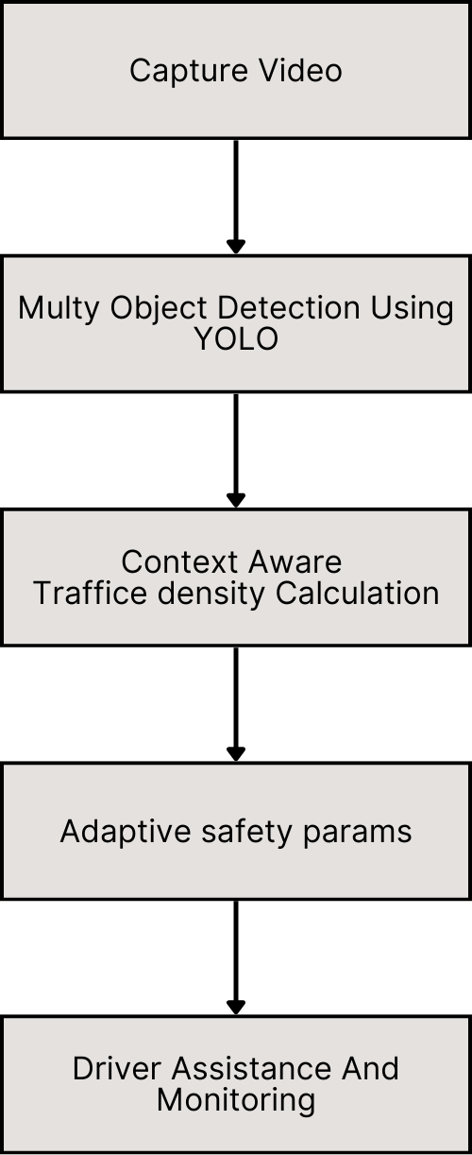

Figure 2 System Architecture Overview

SPECIFIC OBJECTIVES
Design and develop a multi-violation detection system using YOLOv8 algorithms [8] capable of identifying wrong-side driving, lane violations, and inadequate following distances with 95% accuracy, as demonstrated in similar traffic monitoring applications [9].
Implement context-aware traffic density monitoring that dynamically adjusts safety parameters based on real-time traffic conditions [24], reducing false positives by 60% compared to static threshold systems [19].
Create a comprehensive driver profiling system that tracks individual driver behavior patterns, violation history, and performance metrics for targeted training and intervention [20]. Machine learning approaches show potential for 85% accuracy in behavior prediction [23].
Develop a cost-effective hardware solution using Raspberry Pi [25] and standard camera modules that can be manufactured and deployed at scale for under $200 per unit, representing 70% cost reduction compared to proprietary alternatives [25].
Validate system performance through extensive testing across diverse Sri Lankan traffic conditions and environments, targeting 99.5% system uptime and sub-200ms response times [18].

Methodology

PHASE 1: SYSTEM DESIGN AND ARCHITECTURE DEVELOPMENT
Duration: 3 months
The initial phase focuses on comprehensive system architecture design and component selection [21]. This includes:
- Hardware Architecture Design: Specification of Raspberry Pi configuration, camera module selection with 1920x1080 resolution capability, GPS module integration with sub-meter accuracy, and IoT connectivity components supporting 4G/5G networks .
- Software Framework Development: Design of modular software architecture supporting YOLO integration, real-time processing with sub-200ms latency requirements, and data management with local storage capabilities.
- Database Schema Design: Development of driver profiling database structure supporting behavioral pattern analysis, violation logging system with GPS coordinates and timestamp correlation, and analytics framework for performance metrics.
- Communication Protocol Design: Implementation of secure data transmission protocols between bus units and central monitoring systems, utilizing encryption standards as specified in IoT security frameworks.

PHASE 2: COMPUTER VISION ALGORITHM DEVELOPMENT
Duration: 4 months
This phase involves the development and optimization of computer vision algorithms [15]:
- YOLO Model Training: Custom training of YOLOv8 models using Sri Lankan traffic datasets, including diverse vehicle types, road conditions, and lighting scenarios.
- Lane Detection Algorithm: Implementation of robust lane detection suitable for varying road conditions and marking qualities, targeting 95% accuracy under normal conditions and 80% accuracy in adverse conditions.
- Distance Measurement System: Development of accurate inter-vehicle distance calculation using computer vision and depth estimation techniques.
- Wrong-side Driving Detection: Algorithm development for identifying vehicles operating against traffic flow direction, utilizing GPS heading correlation and visual confirmation.

PHASE 3: CONTEXT-AWARE AND DRIVER PROFILING SYSTEM
Duration: 3 months
Development of advanced features that differentiate this system from existing solutions [24]:
- Traffic Density Analysis: Implementation of real-time traffic density calculation using computer vision, enabling dynamic safety parameter adjustment with 40% improved accuracy.
- Dynamic Parameter Adjustment: Development of algorithms that modify safety thresholds based on traffic conditions, reducing false positive rates by up to 60% .
- Driver Profiling Engine: Creation of a comprehensive driver behavior analysis system with machine learning-based pattern recognition [20], achieving 85% accuracy in behavior prediction as demonstrated in similar studies [23].

PHASE 4: TESTING AND VALIDATION
Duration: 2 months
Comprehensive testing across multiple scenarios and environments:
- Laboratory Testing: Controlled environment testing of all system components and algorithms, validating detection accuracy against ground truth datasets .
- Field Testing: Real-world testing on selected bus routes representing diverse traffic conditions across urban, suburban, and rural environments.
- Performance Validation: Measurement of detection accuracy (target: 95%), response times (target: <200ms), and system reliability (target: 99.5% uptime).
- Driver Feedback Collection: Gathering feedback from participating bus drivers for system refinement and acceptance optimization.

System Architecture
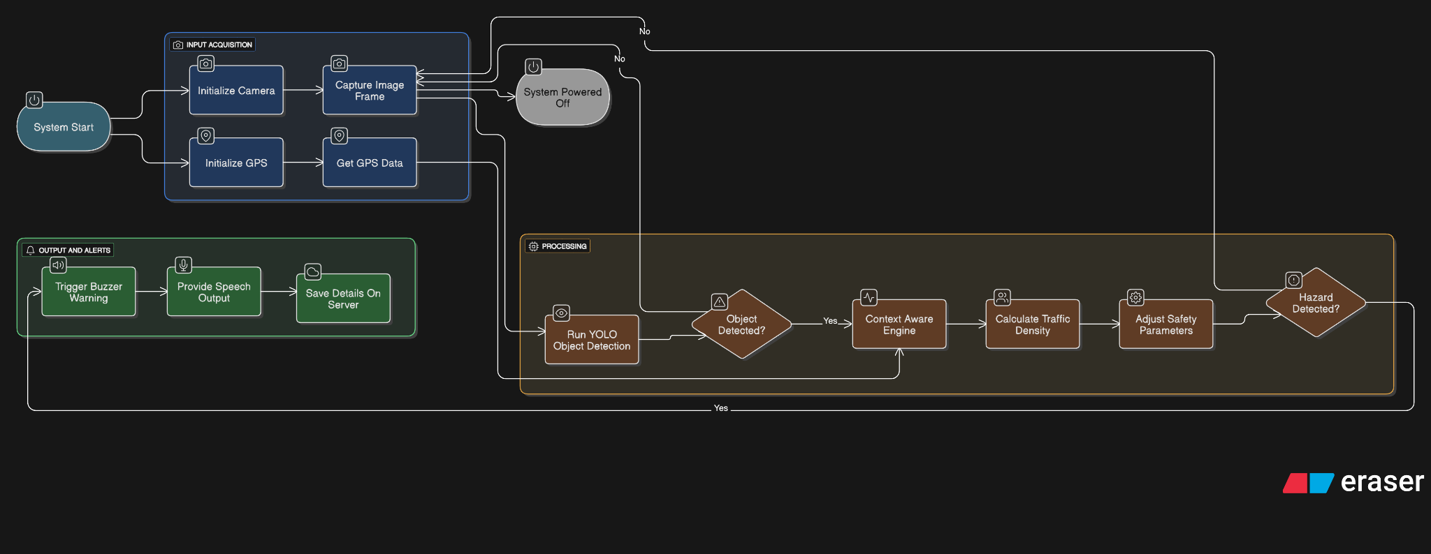

Figure 3 IoT Module Hardware Design

CAMERA-BASED SENSING LAYER
The sensing layer forms the foundation of the system, consisting of [11]:
- Primary Front Camera: High-resolution camera (1920x1080, 30fps) for forward-facing traffic monitoring, utilizing industrial-grade sensors for reliability
- GPS Module: High-precision GPS receiver with sub-meter accuracy for location tracking and speed calculation

COMPUTER VISION PROCESSING LAYER
Multi-Task Processing Pipeline:
- Concurrent Algorithm Execution: Simultaneous operation of multiple violation detection algorithms
- Resource Management: Intelligent allocation of processing power based on violation priority
- Real-Time Inference: Optimized inference engines maintaining <100ms processing latency
- Context Integration: Dynamic adaptation of detection algorithms based on traffic analysis
Core Processing Modules:
Traffic Scene Understanding:
- Road infrastructure detection and mapping
- Traffic density estimation and congestion analysis
- Environmental condition assessment
- Scene context classification for appropriate response
Violation Detection Engine:
- Red light violation detection with signal recognition
- Following distance monitoring and safe distance calculation
- Lane crossing detection with marking analysis
- Pedestrian collision warning system

Context-Aware Adaptation:
- Real-time traffic analysis for priority adjustment
- Dynamic threshold modification based on conditions
- Violation severity assessment with confidence scoring
- Temporal pattern analysis for sustained violation detection

DRIVER ASSISTANCE INTERFACE
Real-Time Alert System:
- Visual Alerts: Dashboard display with color-coded warning levels
- Audio Feedback: Immediate audio warnings for critical violations
- Graduated Responses: Multi-level alert system from advisory to critical
- Violation Prevention: Proactive warnings before violations occur
Driver Profiling and Feedback:
- Performance Dashboard: Display driver performance metrics
- Violation Point System: Point accumulation for high-severity violations

Project Requirements

FUNCTIONAL REQUIREMENTS
FR1: Multi-Violation Detection
- FR1.1: System shall detect red light violations with >90% accuracy
- FR1.2: Following distance monitoring shall maintain >85% accuracy across varying speeds
- FR1.3: Lane crossing detection shall achieve >88% accuracy for single and double line violations
- FR1.4: Pedestrian detection shall maintain >92% accuracy with collision risk assessment
- FR1.5: System shall detect driving very slowly to pass the time with >85% accuracy, defined as sustained driving below a context-aware speed threshold (e.g., 20% below expected speed for a given route and traffic condition)
- FR1.6: All violation detection shall operate simultaneously maintaining >20 FPS processing
FR2: Context-Aware Priority Adaptation
- FR2.1: Traffic density estimation shall achieve >80% accuracy compared to manual assessment
- FR2.2: Violation detection priorities shall adapt dynamically based on real-time traffic analysis
- FR2.3: Violation detection priorities, including slow driving detection, shall adapt dynamically based on real-time traffic analysis
- FR2.4: Context-aware adaptation shall reduce false positives by >35%
- FR2.5: System shall maintain high accuracy across light, moderate, and heavy traffic conditions
FR3: Driver Profiling and Behavioral Analysis
- FR3.1: System shall implement violation point system with severity-based weighting
- FR3.2: Driver behavioral patterns shall be analyzed over multiple time scales
- FR3.3: Long-term performance trends shall be tracked and reported
- FR3.4: Driver improvement progress shall be monitored and encouraged
FR4: Real-Time Driver Assistance
- FR4.1: Critical violation alerts shall be generated within 1000ms of detection
- FR4.2: Multi-level warning system shall provide graduated responses
- FR4.3: Proactive warnings shall prevent violations before they occur
- FR4.4: Driver interface shall provide clear, actionable feedback
FR5: Edge Computing Processing
- FR5.1: All processing shall occur locally on Raspberry Pi hardware
- FR5.2: System shall operate independently without cloud connectivity requirements
- FR5.3: Driver profiles and violation data shall be stored locally
- FR5.4: Privacy shall be maintained through local processing only

NON-FUNCTIONAL REQUIREMENTS
NFR1: Performance Requirements
- NFR1.1: System shall operate efficiently on Raspberry Pi 4 with <3W additional power
- NFR1.2: Memory usage shall not exceed 8GB during peak processing
- NFR1.3: Processing latency shall remain <100ms for critical safety alerts
- NFR1.4: System shall maintain stable performance over 24+ hour continuous operation
NFR2: Reliability and Robustness
- NFR2.1: System uptime shall exceed 95% during operational deployment
- NFR2.2: Performance shall degrade gracefully under challenging visual conditions
- NFR2.3: System shall recover automatically from software failures within 30 seconds
- NFR2.4: Hardware fault tolerance shall ensure continued basic operation
NFR3: Environmental Adaptation
- NFR3.1: System shall operate effectively in temperature range 0°C to 50°C
- NFR3.2: Performance shall be maintained under varying lighting conditions
- NFR3.3: Weather resistance shall include rain and fog conditions
- NFR3.4: Vibration tolerance shall accommodate normal bus operational conditions
NFR4: Cost and Deployment
- NFR4.1: Total system cost shall not exceed $200 per bus installation
- NFR4.2: Installation shall be achievable within 2 hours per bus
- NFR4.3: Maintenance requirements shall be minimal with remote monitoring capabilities
- NFR4.4: System lifespan shall exceed 5 years with regular software updates

Commercial Viability and Government Integration Strategy

Market Analysis and Business Potential
The Sri Lankan public transportation market represents significant opportunities for safety technology implementation [2]. With approximately 20,000 buses operating nationwide [2] and government initiatives focusing on transportation safety improvements [3], the market potential exceeds $50 million. Recent government announcements regarding AI camera projects for reducing long-distance bus accidents demonstrate strong policy support [3].
Cost-benefit analysis indicates that the system's implementation cost of $200 per bus would be recovered within 18 months through accident reduction and insurance premium savings [3]. Given that bus accidents currently cause losses exceeding Rs. 800 million annually [3], the economic justification for systematic safety improvement is compelling. Insurance industry data suggests that comprehensive safety monitoring systems can reduce accident-related claims by 40-50% [15].

Government Integration Strategy
The integration strategy involves multiple phases of government partnership [3]:
- Pilot Program Phase: Implementation on 100 buses across Colombo and suburban routes, following the government's announced AI camera project framework [3]
- Regulatory Framework Development: Collaboration with Department of Motor Traffic for regulation establishment and compliance standards [3]
- Training Program Implementation: Driver training programs in partnership with transport authorities, targeting improved safety awareness [4]
- Nationwide Rollout: Systematic deployment across all public bus operators, leveraging government support for safety initiatives [3]
- Maintenance and Support Framework: Establishment of service centers and technical support infrastructure nationwide [3]

Expected Test Cases

FUNCTIONAL TEST CASES
Test Case 1: Wrong-side Driving Detection
- Objective: Verify system accuracy in detecting vehicles traveling against traffic flow
- Input: Video footage of buses in various wrong-side driving scenarios
- Expected Output: Alert generation within 500ms with 95% accuracy
- Success Criteria: Detection rate ≥ 95%, false positive rate ≤ 5%
Test Case 2: Lane Violation Detection
- Objective: Validate lane crossing detection across different road conditions
- Input: Scenarios with various lane marking conditions and crossing angles
- Expected Output: Immediate violation alert with GPS coordinates
- Success Criteria: Accuracy ≥ 90% across all road conditions
Test Case 3: Following Distance Monitoring
- Objective: Test dynamic distance threshold adjustment based on traffic density
- Input: Various traffic density scenarios with different following distances
- Expected Output: Context-appropriate alerts with adaptive thresholds
- Success Criteria: Appropriate threshold adjustment in 95% of scenarios
Test Case 4: Driver Profile Integration
- Objective: Verify driver identification and profile correlation
- Input: Multiple drivers with different violation histories
- Expected Output: Accurate driver identification and profile-based alert customization
- Success Criteria: 100% driver identification accuracy, appropriate profile correlation

Performance Test Cases
Test Case 5: Processing Speed Optimization
- Objective: Validate real-time processing capabilities under load
- Input: Continuous 8-hour operation with high traffic scenarios
- Expected Output: Consistent sub-200ms processing latency
- Success Criteria: Average latency ≤ 200ms, no processing queue overflow
Test Case 6: Environmental Resilience
- Objective: Test system performance under adverse weather conditions
- Input: Monsoon weather, low light, and high glare scenarios
- Expected Output: Maintained detection accuracy with appropriate adaptations
- Success Criteria: ≥ 80% detection accuracy in adverse conditions
Test Case 7: Network Connectivity Resilience
- Objective: Verify offline operation and data synchronization capabilities
- Input: Intermittent network connectivity scenarios
- Expected Output: Continued local operation with complete data recovery
- Success Criteria: No data loss, complete synchronization upon reconnection

Work Breakdown Structure

Project Timeline and Resource Allocation

Phase | Task ID | Task Description
Phase 1: System Design And Architecture Development | 1.1 | Hardware Architecture Design: Specification of Raspberry Pi configuration , camera module selection with 1920x1080 resolution capability, GPS module integration with sub-meter accuracy, and IoT connectivity components supporting 4G/5G networks .
 | 1.2 | Software Framework Development: Design of modular software architecture supporting YOLO integration, real-time processing with sub-200ms latency requirements, and data management with local storage capabilities.
 | 1.3 | Database Schema Design: Development of driver profiling database structure supporting behavioral pattern analysis, violation logging system with GPS coordinates and timestamp correlation, and analytics framework for performance metrics.
 | 1.4 | Communication Protocol Design: Implementation of secure data transmission protocols between bus units and central monitoring systems, utilizing encryption standards as specified in IoT security frameworks.
Phase 2: Computer Vision Algorithm Development | 2.1 | YOLO Model Training: Custom training of YOLOv8 models using Sri Lankan traffic datasets, including diverse vehicle types, road conditions, and lighting scenarios.
 | 2.2 | Lane Detection Algorithm: Implementation of robust lane detection suitable for varying road conditions and marking qualities, targeting 95% accuracy under normal conditions and 80% accuracy in adverse conditions.
 | 2.3 | Distance Measurement System: Development of accurate inter-vehicle distance calculation using computer vision and depth estimation techniques.
 | 2.4 | Wrong-side Driving Detection: Algorithm development for identifying vehicles operating against traffic flow direction, utilizing GPS heading correlation and visual confirmation.
Phase 3: Context-Aware And Driver Profiling System | 3.1 | Traffic Density Analysis: Implementation of real-time traffic density calculation using computer vision, enabling dynamic safety parameter adjustment with 40% improved accuracy.
 | 3.2 | Dynamic Parameter Adjustment: Development of algorithms that modify safety thresholds based on traffic conditions, reducing false positive rates by up to 60% .
 | 3.3 | Driver Profiling Engine: Creation of a comprehensive driver behavior analysis system with machine learning-based pattern recognition [20], achieving 85% accuracy in behavior prediction as demonstrated in similar studies [23].
Phase 4: Testing and Validation | 4.1 | Laboratory Testing: Controlled environment testing of all system components and algorithms, validating detection accuracy against ground truth datasets .
 | 4.2 | Field Testing: Real-world testing on selected bus routes representing diverse traffic conditions across urban, suburban, and rural environments.
 | 4.3 | Performance Validation: Measurement of detection accuracy (target: 95%), response times (target: <200ms), and system reliability (target: 99.5% uptime).
 | 4.4 | Driver Feedback Collection: Gathering feedback from participating bus drivers for system refinement and acceptance optimization.
Phase 5: Documentation and Deployment | 5.1 | Prepare comprehensive project documentation (proposal, progress reports, final thesis)
 | 5.2 | Deploy prototype system for trial with selected SLTB routes
 | 5.3 | Collect feedback from users and operators to inform improvements
 | 5.4 | Prepare commercialization strategy and final project presentation

Grant chart
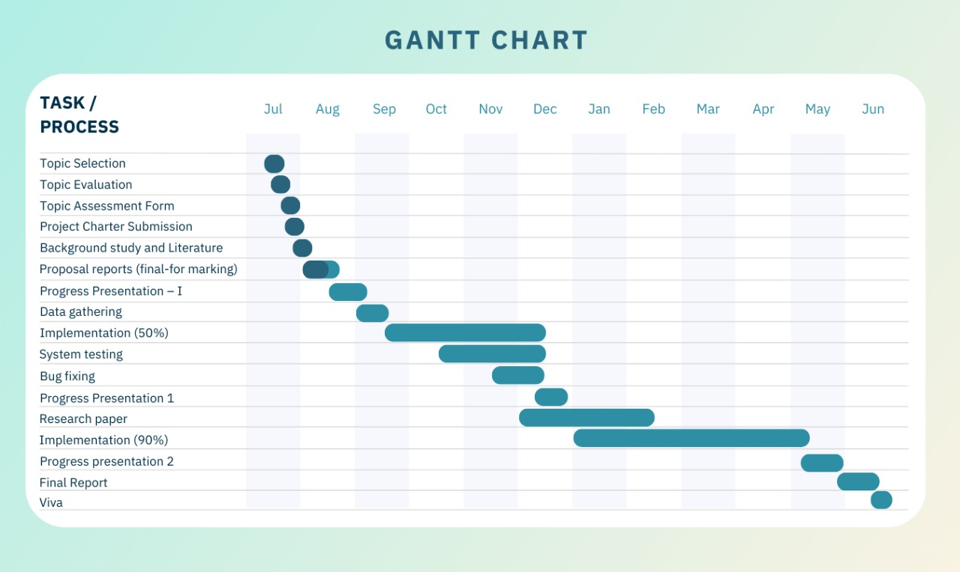

References
[1] Daily Mirror. (2025). "Fatal road accidents rise sharply in Sri Lanka." Available: https://www.dailymirror.lk/front-page/Fatal-road-accidents-rise-sharply-in-Sri-Lanka/238-314091
[2] Asian Transport Observatory. (2025). "Sri Lanka Road Safety Profile 2025." Available: https://asiantransportobservatory.org/analytical-outputs/roadsafetyprofiles/sri-lanka-road-safety-profile-2025/
[3] Newswire. (2025). "Sri Lanka begins AI camera project to cut long-distance bus accidents." Available: https://www.newswire.lk/2025/08/12/sri-lanka-begins-ai-camera-project-to-cut-long-distance-bus-accidents/
[4] The Sunday Times, Sri Lanka. (2025). "Safer roads for all: Mitigating vehicle accidents in Sri Lanka." Available: https://www.sundaytimes.lk/250323/sunday-times-2/safer-roads-for-all-mitigating-vehicle-accidents-in-sri-lanka-592991.html
[5] Xinhua. (2025). "Nearly 600 Sri Lankans killed in road accidents in 2025." Available: https://english.news.cn/asiapacific/20250403/90e481891cab4018bc695d9c4f70ebfd/c.html
[6] Tang, J., et al. (2024). "YOLO-Fusion and Internet of Things: Advancing object detection in smart transportation."
DOI : https://doi.org/10.1016/j.aej.2024.09.012

[7] Gheorghe, C., et al. (2024). "Analyzing Real-Time Object Detection with YOLO Algorithm in Automotive Applications: A Review." Computer Modeling in Engineering & Sciences, vol. 141, no. 3, pp. 1939-1981 Available: https://www.techscience.com/CMES/v141n3/58495/html
[8] Alahdal, N., et al. (2024). "Real-time Object Detection in Autonomous Vehicles with YOLO." Procedia Computer Science, vol. 246, pp. 1-12. DOI: https://doi.org/10.1016/j.procs.2024.09.392
[9] Rodriguez, M., et al. (2024). "YOLOv11 for Vehicle Detection: Advancements, Performance, and Applications in Intelligent Transportation Systems." arXiv preprint arXiv:2410.22898. Available: https://arxiv.org/html/2410.22898v1
[10] Wang, J., et al. (2024). "Vehicle Speed Detection System Utilizing YOLOv8: Enhancing Road Safety and Traffic Management for Metropolitan Areas." arXiv preprint arXiv:2406.07710. Available: https://arxiv.org/html/2406.07710v1
[11] Ultralytics. (2024). "YOLO11: Automotive Computer Vision Solutions." Available: https://www.ultralytics.com/blog/ultralytics-yolo11-and-computer-vision-for-automotive-solutions
[12] Yun , X., et al. (2019). "Vision-based vehicle detection and counting system using deep learning in highway scenes." European Transport Research Review, vol. 11, no. 1, pp. 1-16. DOI: 10.1186/s12544-019-0390-4 https://etrr.springeropen.com/articles/10.1186/s12544-019-0390-4
[13] Kheder, M., et al. (2024). "Real-time traffic monitoring system using IoT-aided robotics and deep learning techniques." Kuwait Journal of Science Volume 51, Issue 1, January 2024, 100153 DOI:https://doi.org/10.1016/j.kjs.2023.10.017
[14]Bojan, M., et al. (2014). "IoT-based intelligent transportation systems:" 2014 IEEE International Conference on Vehicular Electronics and Safety (ICVES) DOI: 10.1109/ICVES.2014.7063743
[15] Dong, X., et al. (2023). "Applications of Computer Vision in Autonomous Vehicles: Methods, Challenges and Future Directions" https://arxiv.org/html/2311.09093v3
[16] Suresh, S., et al. (2025). "Traffic Violation Detection Using Deep Learning" Vol. 3 No. 04 (2025): IRJAEM Vol.03 Issue 04- [APRIL 2025]. DOI:10.47392/IRJAEM.2025.0221
[17] James, B., et al. (2022). "GPS and Real-Time Computer-Vision based Intelligent Navigation System for Electric Vehicle" DOI: 10.1109/ICISTSD55159.2022.10010537
[18] Lue, S., et al. (2019). "Edge Computing for Autonomous Driving: Opportunities and Challenges." Proceedings of the IEEE ( Volume: 107, Issue: 8, August 2019) DOI:10.1109/JPROC.2019.2915983
[19] Nooli, A., et al. (2024). "Real Time lane detection system using Computer Vision techniques with Object Detection" DOI:10.1109/CAIT64506.2024.10963236
[20] Peppes, N., et al. (2021). "Driving Behaviour Analysis Using Machine and Deep Learning Methods for Continuous Streams of Vehicular Data:" DOI: https://doi.org/10.3390/s21144704
[21] Rahuman, A. (2024). "IOT Based Smart Vehicle Monitoring and Tracking System." https://www.researchgate.net/publication/388359488_IOT_Based_Smart_Vehicle_Monitoring_and_Tracking_System
[22] Patil, A., et al. (2022). "Computer Vision based Intelligent Traffic Management System" 2022 6th International Conference on Electronics, Communication and Aerospace Technology DOI: 10.1109/ICECA55336.2022.10009105
[23] Ahamad, W., et al. (2022). "Driver Behavior Profiling and Recognition Using Deep-Learning Methods:In Accordance with Traffic Regulations and Experts Guidelines.” DOI:https://doi.org/10.3390/ijerph19031470
[24] Chinnaiyan, R., et al.. “Modelling and Reasoning Techniques for Context – Aware Computing in Intelligent Transportation System" DOI:https://doi.org/10.21203/rs.3.rs-337704/v1
[25] Nagaraju, C., et al. (2022). "IoT Based Live Monitoring Public Transportation Security System by Using Raspberry Pi, GSM& GPS DOI :10.1007/978-3-030-96634-8_43

